CSA5103 – Cryptography and Network Security
Lab Experiments

Exp.No-2

- Write a C program for monoalphabetic substitution cipher maps a plaintext alphabet to a ciphertext alphabet, so that each letter of the plaintext alphabet maps to a single unique letter of the ciphertext alphabet.

Aim:
To implement the Monoalphabetic Substitution Cipher using Python for encryption and decryption.

Algorithm:
- Start the program.
- Read the plaintext message.
- Define the plaintext alphabet (A-Z).
- Define a unique ciphertext alphabet (substitution key).
- Encrypt the message by replacing each letter with its corresponding ciphertext letter.
- Display the encrypted message.
- Decrypt the ciphertext by replacing each letter with its original plaintext letter.
- Display the decrypted message.
- Stop the program.

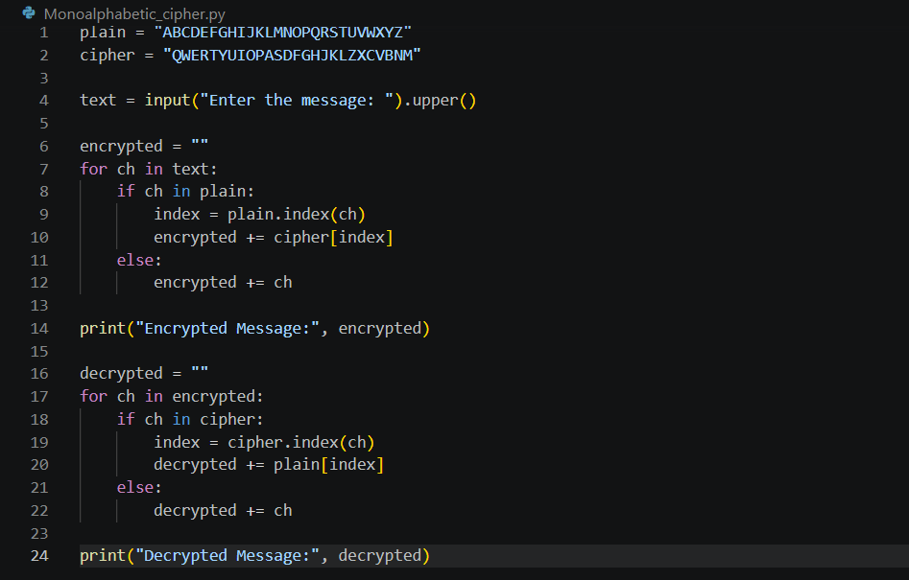
Program:

Output:
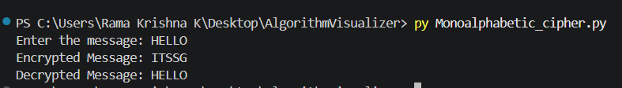

Result:
The Monoalphabetic Substitution Cipher was successfully implemented using Python. The plaintext was encrypted by substituting each letter with a unique ciphertext letter, and the original plaintext was successfully recovered through decryption.

